Chad Carmickle M03 Create the Invoice Total App 1/30/19

Devices I used to test on:

Nexus 4 API 26 768 x 1280:xhdpi

Nexus 5 API 26 1080 x 1920:420 dpi

Samsung Galaxy S7 API 26 1440 x 2560 xxxhdpi

Description

This is a continuation upon the previous tip calculator, last time we left off with the tip calculator having only a few labels and an edit box. Upon reviewing comments made, I have updated the text view to have a hint text that says “Enter Amount” that way users can just tap and type without having to backspace.

Added various comments to the text section of the Activity Main Xml to show where certain portions of the code would affect which label and text on the project.

New Features

New Features that will be added to this section of the app will include

* Event Handlers and listeners
* Allow the app to create a discount amount value and Total value based on the number enter in the Subtotal textbox.

Bugs

When attempting the step to add the listener I ran into an error.

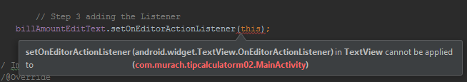

Another bug happened to occur after I tried to code in the Override for the fourth step of the Listener.

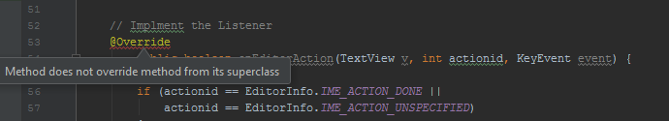

Once I scrapped the project and restarted I never ran into anymore bugs similar to these.

Reflection.

I had some fun with the app it was nice seeing how event handlers were added and how to gain input from the user. It seemed simple at first but being out of practice with code for a year really set me back to trying to remember what simple things did and double checking if I had ended my code with a semicolon. I had to review the chapter a few times to understand what I was typing and doing but after some time It started to come back. After some testing I found that my app for some reason just closes I tried to run it on my physical device. An error message saying “**Invoice Total has Stopped**” appeared when trying to test. I later found the error being a missing semicolon.

The hardest thing I had to was trying to figure what the textbook was wanting. From the various keywords and things, I wasn’t familiar with and seeing it threw me off a lot. Trying to reference my code with the textbook was a big mistake, I ended up adding more stuff to my code that I didn’t understand and at that point I was so confused at what I was doing none of it made sense. I ended up scraping the project, reread the chapters and watched some Android video tutorials to gain a better understanding and then retry the assignment. I got much farther than before what ended up in nearly the same spot. Once out of all ideas and clue I asked Chris for his input and once he told me to go by the picture something just clicked. I was able to easily add what I felt was needed, include the variables one by one that I need and flew through the project in under two hours what when I followed the book took me hours to do. The only trouble I had was near the end when I had to output the numbers in the correct decimal format, and that just took an hour of research about decimal format.

